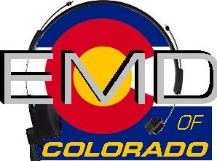
EMD Basic Provider Course 2017-06-P

December 13-15
Class times will be 9 am to 7 pm.
Morning and afternoon snacks will be provided, lunch on your own.
All Students MUST have a current CPR card or a letter from their agency.
Cost: $225.00
Hosting Agency: ADCOM 911
Location : TBD BY SPONSORING AGENCY

Name______________________________________________________________
Agency_____________________________________________________________
Agency Address______________________________________________________
Agency Phone_______________________________________________________
Student E-mail_______________________________________________________
Agency EMD Coordinator/Supervisor_____________________________________
Agency EMD Coordinator/Supervisor Phone_______________________________
Agency EMD Coordinator/Supervisor E-mail_______________________________

Please email registrations to : Jackie Reynolds- jreynolds@adcom911.org
Registration Deadline- December 8, 2017

Check appropriate:
Check (payable to EMD of Colorado) mailed to 611 Oak St. Salida, CO 81201 __________
Check (payable to EMD of Colorado) being brought to class__________
Voucher(s) attached in the amount of______________________

