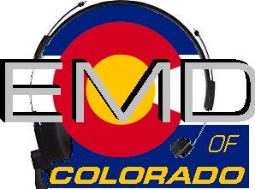
EMD Instructor Course #22-1-I
DATE: August 1-5, 2022
(includes internship for completion of Instructor course)
Class Times: 0900-1700

Morning and afternoon snacks will be provided, lunch on your own.
All Students MUST have a current CPR card or a letter from their agency.
Cost: $150.00
Hosting Agency: Chaffee County Sheriff
Location: August 1 TBD + August 2-5 @ Salida Multi-use Facility; 8154 W Hwy 50; Salida, CO 81201

Name______________________________________________________________
Agency_____________________________________________________________
Agency Address______________________________________________________
Agency Phone_______________________________________________________
Student E-mail_______________________________________________________
Agency EMD Coordinator/Supervisor_____________________________________
Agency EMD Coordinator/Supervisor Phone_______________________________
Agency EMD Coordinator/Supervisor E-mail_______________________________

Please email/fax registrations to: Instructor- Jet Stephens jstephens@chaffeesheriff.org. FAX: (719) 539-3648

Registration Deadline- July 25, 2022
Check appropriate:
Check (payable to EMD of Colorado) mailed to 11268 CR 198; Nathrop, CO 81236 __________
Check (payable to EMD of Colorado) being brought to class__________
Voucher(s) attached in the amount of______________________

