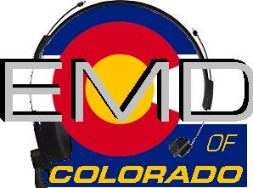
EMD Basic Provider Course #22-2-P
DATE: Aug 2nd– 5th, 2022
Class Times: 0900-1700

Morning and afternoon snacks will be provided, lunch on your own.
All Students MUST have a current CPR card or a letter from their agency.
Cost: $225.00
Hosting Agency: Chaffee County
Location: Salida Multi-use Facility/8154 W Hwy 50/Salida, CO 81201

Name______________________________________________________________
Agency_____________________________________________________________
Agency Address______________________________________________________
Agency Phone_______________________________________________________
Student E-mail_______________________________________________________
Agency EMD Coordinator/Supervisor_____________________________________
Agency EMD Coordinator/Supervisor Phone_______________________________
Agency EMD Coordinator/Supervisor E-mail_______________________________

Please email or fax registrations to: Jet Stephens jstephens@chaffeesheriff.org or (719) 539-3648
Registration Deadline- July 25th, 2022

Check appropriate:
Check (payable to EMD of Colorado) mailed to 11268 CR 198; Nathrop, CO 81236 __________
Check (payable to EMD of Colorado) being brought to class__________
Voucher(s) attached in the amount of______________________

