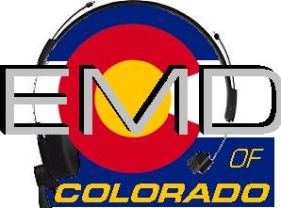
EMD Basic Provider Course #22-3-P
DATE: June 27th – 29th, 2022
Class Times: 0800-1800

Morning and afternoon snacks will be provided, lunch on your own.
All Students MUST have a current CPR card or a letter from their agency.
Cost: $225.00
Hosting Agency: Gilpin County Sheriff’s Office
Location: 2960 Dory Hill Rd; Black Hawk CO 80422

Name______________________________________________________________
Agency_____________________________________________________________
Agency Address______________________________________________________
Agency Phone_______________________________________________________
Student E-mail_______________________________________________________
Agency EMD Coordinator/Supervisor_____________________________________
Agency EMD Coordinator/Supervisor Phone_______________________________
Agency EMD Coordinator/Supervisor E-mail_______________________________

Please email registrations to: Marie Romero mromero@gilpincounty.org
Registration Deadline- June 20th, 2022

Check appropriate:
Check (payable to EMD of Colorado) mailed to 11268 CR 198; Nathrop, CO 81236 __________
Check (payable to EMD of Colorado) being brought to class__________
Voucher(s) attached in the amount of______________________

