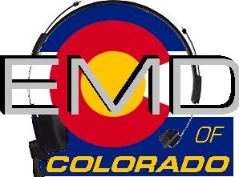
EMD Basic Provider Course #22-4-P
DATE: June 6th– 8th, 2022
Class Times: 0800-1800

Morning and afternoon snacks will be provided, lunch on your own.
All Students MUST have a current CPR card or a letter from their agency.
Cost: $225.00
Hosting Agency: Lincoln County
Location: 130 C Avenue Limon, CO 80828

Name______________________________________________________________
Agency_____________________________________________________________
Agency Address______________________________________________________
Agency Phone_______________________________________________________
Student E-mail_______________________________________________________
Agency EMD Coordinator/Supervisor_____________________________________
Agency EMD Coordinator/Supervisor Phone_______________________________
Agency EMD Coordinator/Supervisor E-mail_______________________________

Please email registrations to: Rachel Born rborn@co.grand.co.us
Registration Deadline- June 3rd

Check appropriate:
Check (payable to EMD of Colorado) mailed to 11268 CR 198; Nathrop, CO 81236 __________
Check (payable to EMD of Colorado) being brought to class__________
Voucher(s) attached in the amount of______________________

**Holiday Inn Express will provide a promotional rate if name and agency is given at the time of registration.

